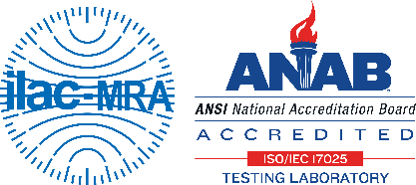
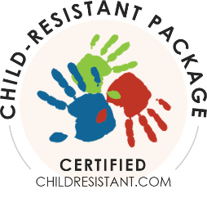
Thank you for having Great Lakes Marketing conduct your child resistant package protocol testing. We are accredited to test child resistant packages (ISO 17025) according to 16CFR1700 (the US standard) and all relevant international standards. We are also an accredited certifying body (ISO 17065). This form is vital for us to document the test procedures in full, so the final report meets the requirements of the regulation. Please complete each box. If you have questions, please email: SafeChild@GLM.com
Contact for updates & report: | Name/Title:
 | Company:
 | Email Address/Phone:

Company address of record: | Address:  City/State/Zip:
Location where packages made: | Address:  City/State/Zip: if same as above
Location where packages were prepared for testing: | Address:  City/State/Zip: if same as above
Describe all procedures for preparing the test packages (including if the packages were cycled*): | *Cycled means opened/closed to simulate expected lifetime use.
Purchase Order #:

PACKAGE TYPE
(fill in name, check box below and complete additional information if required)

Package Name: | (This is the name that will be used in the report; this must be filled in.)
Panel Size (x): | Child: 50 (full panel) Mini 10 (for R&D purposes only)  Senior: 100 (full panel) Mini 20 (for R&D purposes only)  Resecure: 100/100 (full panel) Mini 20/20 (for R&D purposes only)
- Re-closeable (continuous thread cap) | The report must state the torque value if the caps are on the containers. If we are to apply the caps, please provide the expected torque level.  Actual or expected torque value: ________________  If caps were applied, date/time last cap applied: ________________
- Cap and Container | Any cap/bottle package that is not torque dependent.
- Unit Dose | The report must state the failure level (the number of units that could cause harm/serious injury to a child).  Failure level: _________________  Number of pills/tablets on each card: _________________
- Other | (i.e., pouch, box, etc.) (for pouches/sachets please include failure level)  Failure level: _________________
We test according to the US standards (16CFR1700). If you need to meet other requirements, please check the box (we are accredited to test to all standards). | - CPSC 16CFR1700 (US)  - EPA (US)  - CSA (Canadian) | - ISO (International)  - ASTM 2517 (Portable Fuel Containers)

COMPONENT B (as needed)
(i.e., cap, attached outer box, etc.)
Description:
Manufacturer:
Material & Color:
Code Number:
Lot Number:
Sealing Method/Temp:
Closure Liner Material:
Drawing/Ref Numbers/Other:
The regulations require that the package definition be as detailed as possible. Please complete as much of this information as possible. This information will be included in the report. Complete the information for each component of your package.
COMPONENT A
(i.e., bottle, container, card, etc.)
Description:
Manufacturer:
Material & Color:
Code Number:
Lot Number:
Sealing Method/Temp:
Drawing/Ref Numbers/Other:

Your checklist of items to send to Great Lakes Marketing: (Great Lakes Marketing, 3361 Executive Parkway, Suite 200, Toledo, Ohio 43606)
- This 2-page form (email this to us and enclose in the box if you can)
- Packages (carefully packed so there is no damage in transit)
- A memo detailing the placebo contents (if a placebo is included) (due to allergies food should not be used)
- Opening directions (that match the final directions) (if not on the package they can be on a separate page using the same size, font, etc.)
- The package must retain CR properties for the expected life of the package. You will need documentation that this requirement has been met (or packages can be cycled).
You will receive:
- An email when your packages arrive
- An email confirming we have everything we need and can start testing
- Periodic updates during the testing (about 2 to 3 times a week)
- A full report (hard copy) and PDF on a flash drive
- A Certificate of Conformity template (that you may choose to publish on your company website)
If you would like your samples returned, please provide your FedEx or UPS #, otherwise your samples will be destroyed:

FedEx #: ______________________________
UPS #: ________________________________

If you would like your package certified (per ISO 17065), please check this box □ and we will send the Certification Packet. Certification offers several benefits, such as a seal to place on your marketing materials, a listing on ChildResistant.com, archival services, etc. Certification is an additional fee.
Client Signature: ____________________________________________ (digital accepted) | Date: _______________
Reviewer Signature: __________________________________________ | Date: _______________

